**LEBANESE AMERICAN UNIVERSITY**

**USAID – HIGHER EDUCATION SCHOLARSHIP PROGRAM**

**HES - Volunteering Program Verification Form**

This form is to be used to document volunteering hours. If a student volunteers for multiple organizations, a separate form must be used for each organization. **This form must be turned in by the 28th of each month, the latest.**

I certify that the scholar Saad Alahmadieh completed a total of 40 hours of service at InnovaThrive.

The hours were completed hours as per the below:

Hours # 10 (date) _2/12 – 6/12_ (initials of supervisor) __A.K.___

Hours # 10 (date) _9/12 – 13/12_ (initials of supervisor) __A.K.___

Hours # 10 date) _16/12 – 20/12 (initials of supervisor) __A.K.___

Hours # 10 date) _23/12 - 27/12 (initials of supervisor) __A.K.___

Brief description of the activities the scholar performed or participated in:

As Chief of Staff at InnovaThrive, I streamline the CEO's operations by coordinating strategic initiatives, facilitating communication across departments, and managing key projects. I ensure alignment between the COO team and CEO team, support decision-making with actionable insights, and oversee the efficient execution of organizational priorities. My role is pivotal in enhancing collaboration and driving organizational success. In general, I am responsible for overseeing the development and growth of the staffing in the managerial team and ensuring the integration of new staff members, and driving continuous improvements in our internal processes. I am also committed to enhancing InnovaThrive's public image, ensuring all communications reflect our core values and promoting professionalism and a strong public presence.

Written feedback about the scholar’s performance:

Saad Alahmadieh has demonstrated exceptional leadership and managerial skills through his extensive volunteer work with InnovaThrive. His strengths in strategic planning and risk management have effectively aligned initiatives with the organization's mission. Saad's commitment to professional development enhances team performance and fosters a culture of continuous improvement, making him a valued leader within the organization.

Please rate the overall performance of the scholar at your organization:

|  |  |  |  |
| --- | --- | --- | --- |
|  | Mastery (5) | Proficient (3) | Emerging (1) |
| **Problem solver** | X |  |  |
| **Engaged & Committed** | X |  |  |
| **Open-minded & multicultural** | X |  |  |

Signature

& stamp

__________________________

_

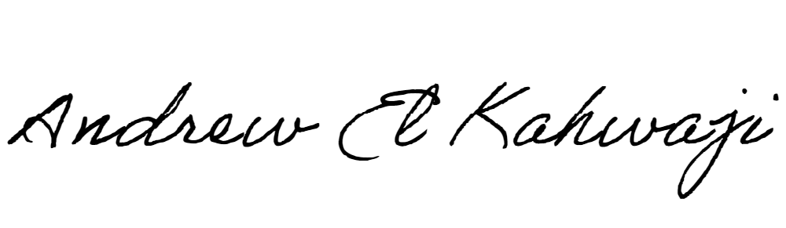

Printed Name _Andrew El Kahwaji_

Date __26/12/2024___

Email __andrew.lifesculptor.coo@gmail.com __

Phone __+961 71 914 378__